Personal project
Student name | John Wallis
Student number
School Name | Helena College Senior School
School number
Supervisor name | Lyndsey Moffit

Title of the project:
Gabion Sculptures

Goal of the project:
“To Research and build a landscaped section of the family garden”

Length: (word count)

To be included when submitting the project report:

A completed academic honesty form | 
Process journal extracts (10 maximum) | 
Reference list | 


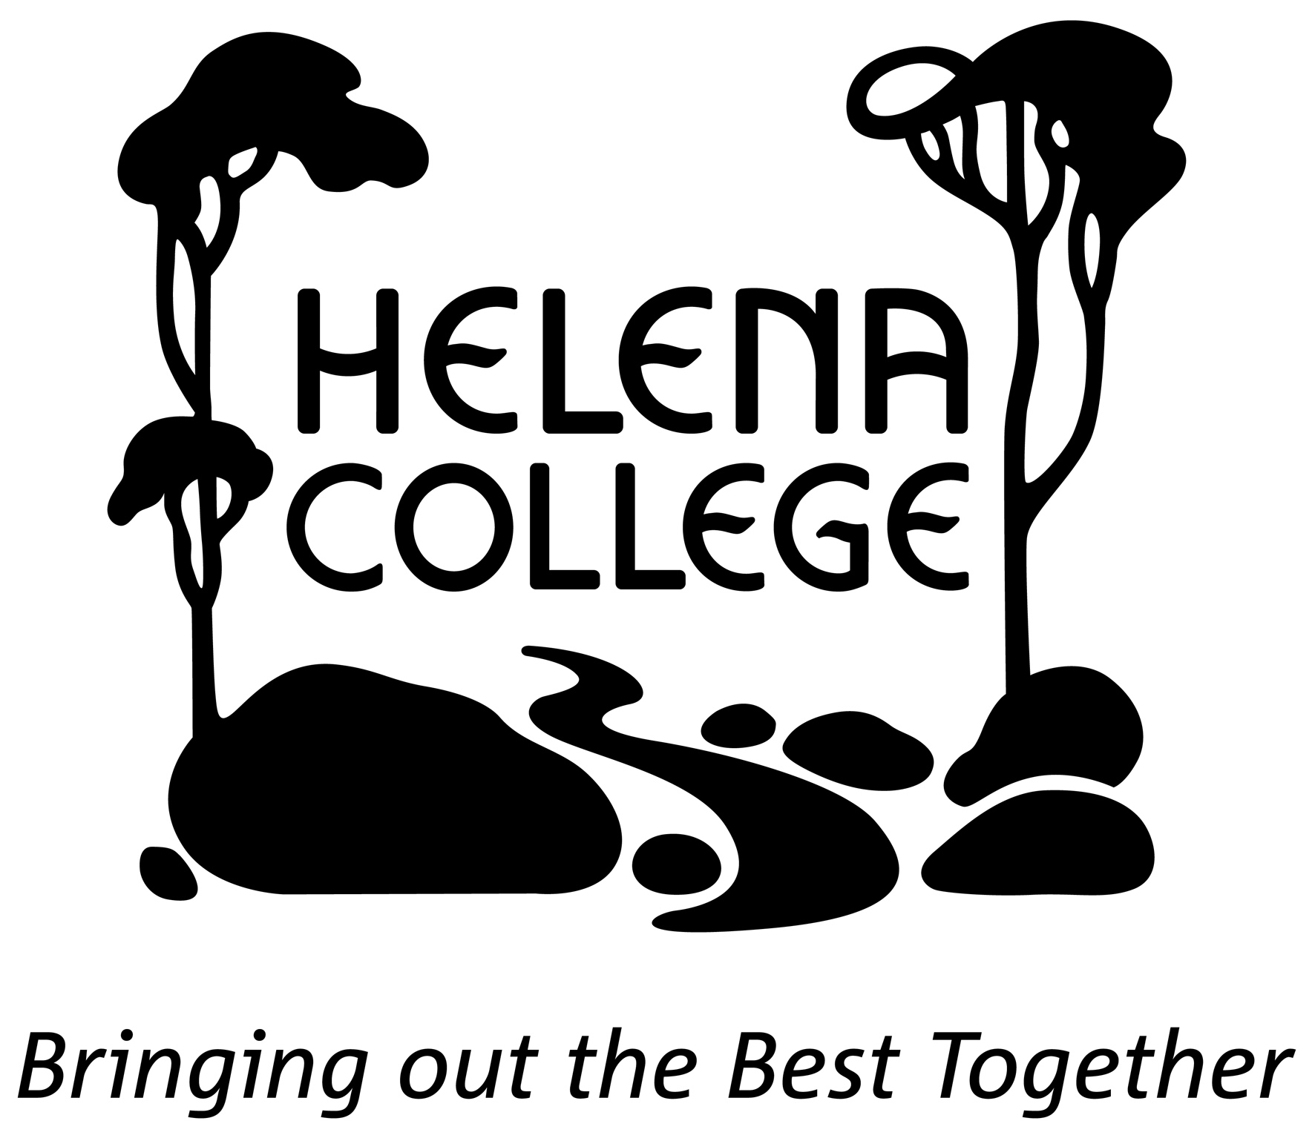

MYP PP academic honesty form

Student name
Student number
School Name | Helena College Senior School
School number |  |  |  |  | 3 | 0 | 0 | 3 | 8 | 9
Supervisor name

Student: This document records your progress and the nature of your discussions with the supervisor. You should aim to see your supervisor at least three times: at the start of the process to discuss your initial ideas, then once you have completed a significant amount of your project, and finally once your completed report/presentation has been submitted.

Supervisor: You are asked to have at least three supervision sessions with students, one at the start of the process, an interim meeting and then the final meeting. Other sessions are permitted but do not need to be recorded on this sheet. After each session, students should make a summary of what was discussed and you should sign and date these comments.

 | Date | Main points discussed | Signature
Meeting 1 |  |  | Student:  Supervisor:

Meeting 2 |  |  | Student:  Supervisor:
Meeting 3 |  |  | Student:  Supervisor:
Supervisor comment

Student declaration
I confirm that this work is my own and this is the final version. I have acknowledged, in the body of my work, each use of the words, work or ideas of another person, whether written, oral or visual (hard copy and/or electronic materials).
Supervisor declaration
I confirm that, to the best of my knowledge, the material submitted is the authentic work of the student.
Student’s signature | Date
Supervisor’s signature | Date

Contents

Page
number

A. Investigating 6
i. Defining a goal
ii. Linking to prior experiences
iii. Demonstrating research skills

B. Planning 8
i. Developing criteria
ii. Creating development process
iii. Demonstrating self-management skills

C. Taking action 9
i. Creating the product
ii. Demonstrating thinking skills
iii. Demonstrating communication and social skills

D. Reflecting 10
i. Evaluating the product
ii. Reflecting on personal project experience
iii. Reflecting on IB development

Bibliography 12

Appendix 13

A. INVESTIGATING

i) Defining a goal

- The goal of my Project was “to Research and Build a landscaped section of the family garden” this goal is clear and highly challenging because the goal is something that is new to me that I have not done much of before and will require effort to complete.

The global context I chose to guide me through the project was “Scientific and Technical Innovation” I chose this because through my project I would be focusing on the construction techniques that I need to create a landscaped sculpture (explain how your topic has been enhanced by this global context)

Bookm

ii) Linking to prior experiences

- I chose this project because

One of the reasons why I wanted to follow this path for my personal project was an experience …. (link to your prior learning and subject-specific experiences).

You must make mention of both your prior learning and subject-specific knowledge.

iii) Demonstrating research skills

Write a brief introduction to indicate why you needed to conduct research.

You will need to include in this section information on how your research enabled you to complete the project and to successfully meet your criteria.

Write one to two paragraphs on the primary sources that you used to complete the project:
- what you learnt from the sources,
- what information you applied to your project from the sources,
- and the effect they had on your project.

Write one to two paragraphs on the secondary sources that you used to complete the project:
- what you learnt from the sources,
- what information you applied to your project from the sources,
- and the effect they had on your project.

Remember to refer constantly to your process journal.

To receive a level 7-8 for Criterion A you must have a at least 10 sources, critically analyses and evidenced in your process journal. There must also be a variety of sources.

Remember to use the correct Helena College style for your in-text referencing. You can get the in-text referencing when you generate the bibliography entry from the online generator.

B. PLANNING
- (This section should have approximately 850 words)

i) Developing criteria

Describe your product.

- To judge the success of my goal I created a set of criteria. They were:
- insert
- insert
- insert
- insert
- insert

Describe how you developed the criteria you used to create it.

ii) Creating development process

Describe how you created your development process (steps to success) and how it helped you to complete your product.

Emphasis the links between your 5 criteria and the development process.

iii) Demonstrating self-management skills

Explain how you have developed, enhanced, managed your project using the listed ATL self-management skills. Perhaps refer to the checklist (you might also want to put this in your appendix) that appears on page 31 of the student booklet.

Explain how you used your time wisely. Perhaps use your ATL checklists from meetings 3, 7 and 10 to demonstrate how they have been developed during the personal project.

C. TAKING ACTION
- (This section should have approximately 850 words)

i) Creating the product

Write an introductory paragraph to say if you achieved or didn’t achieve your goal. Why or why not?

Describe, in detail, how you created your product.

Explain why you changed your goal statement if this occurred.

Does your product reflect the global context you chose?

Conclude this section by discussing what would you do differently and why on your product, if you had to do the project again.

ii) Demonstrating thinking skills

Explain how you have developed, enhanced, managed your project using the listed ATL thinking skills. Perhaps refer to the checklist (you might also want to put this in your appendix) that appears on page 30 of the student booklet.

iii) Demonstrating communication and social skills

Explain how you have developed, enhanced, managed your project using the listed ATL communication and social skills. Perhaps refer to the checklist (you might also want to put this in your appendix) that appears on page 33 of the student booklet.

D. ReflectiNG
- (This section should have approximately 850 words)

i) Evaluating the product

Explain why or why not you are happy with the final outcome. For each criteria explain how you met or did not meet each target.

What did you learn about your project/topic across the last 9 months…

Mention here the expense (perhaps it might have been different to your initial expectation), and/or amount of time spent.

You might make reflections on your successes and / or possible disappointments. If faced with a problem or challenge, how did you overcome it.

ii) Reflecting on personal project experience

I learnt the following about my topic…

I learnt these things about my global context...

I valued the opportunity to work with my supervisor who…

I valued the opportunity to meet and work with an excellent mentor who…

What did you learn about yourself? For example, I need to improve my organisation; I learnt to reference correctly.

iii) Reflecting on IB development

In this section explain how you have developed as an IB inquiring student making reference to at least three of the IB learner profiles. In relation to these characteristics, explain how your personal project has made you a better learner.

You might make recommendations for future PP students.

You might make reflections on what you would do your PP differently if you had the opportunity to complete a PP again!

Conclusion - Final paragraph (if you have enough words and without repeating yourself)

Sum up the value of the personal project to your future learning path and acknowledge that you have survived the challenge.

BIBLIOGRAPHY

This needs to be on a separate page.

Remember to use the Helena College Online Bibliography Generator.

- List, in alphabetical order, those sources used within your report.

- AppendiCES

- This needs to be on a separate page.

(You must have a maximum of 10 extracts on 10 pages from your process journal in order to meet IB requirements.)

Below is an example of how to label your appendices.

Appendix 1: insert title

- This is a copy of/ photo of/ chart of/
- I got this from
- This appendix explains/illustrates/......about my project.

Appendix 2: insert title

- This is a copy of/ photo of/ chart of/
- I got this from
- This appendix explains/illustrates/......about my project.

